ProjectDesignPhase-II

DataFlowDiagram&UserStories

Date | 19February2026
Team ID | LTVIP2026TMIDs66458
ProjectName | GeminiHistoricalArtifactDescription
MaximumMarks | 4 Marks

DataFlowDiagrams:
A Data Flow Diagram (DFD) is a traditional visual representation of the information flows within a system. A neat and clear DFD can depict the right amount of the system requirement graphically. It shows how data enters and leaves the system, what changes the information, and where data is stored.
Example:
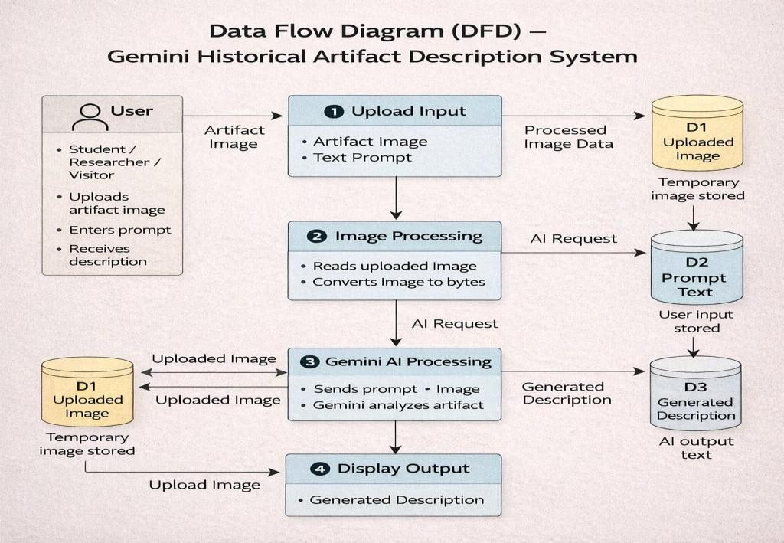

UserStories

UserType | Functional  Requirement (Epic) | UserStory Number | UserStory/Task | Acceptancecriteria | Priority | Release
Customer(Web User – Student/Resear  cher) | Access Application | USN-1 | Asauser,Icanopenthewebapplicationinmy browser. | Application loads successfully and home page is visible | High | Sprint-1
Customer(Web  User) | UploadImage | USN-2 | Asauser,Icanuploadanimageofahistorical  artifact. | Imagepreviewisdisplayed  afterupload | High | Sprint-1
Customer(Web  User) | EnterPrompt | USN-3 | Asauser,Icantypeanartifactnameor  descriptionprompt. | Textinputboxaccepts  userinput | High | Sprint-1
Customer(Web  User) | Generate  Description | USN-4 | Asauser,Icanclick“GenerateArtifact  Description”button. | AIgeneratesandshows  descriptiononscreen | High | Sprint-1
Customer(Web User) | ViewResult | USN-5 | Asauser,Icanreadthedetailedhistorical description generated by AI. | Descriptionincludesorigin, period, material, and  significance | High | Sprint-1
Customer(Web  User) | InterestingFact | USN-6 | Asauser,Icanseeahistoricalfactwhilethe  systemisprocessing. | Historical fact message  appearsduringloading | Medium | Sprint-2
Customer(Web  user) | ErrorHandling | USN-7 | Asauser,Igetanerrormessageifnoimage  isuploaded. | Systemshows“Nofile  uploaded”message | High | Sprint-1
Customer(Web  User) | APIConfiguration | USN-8 | Asanadmin,IcanconfiguretheGeminiAPI  keysecurely. | APIkeystoredin.envand  systemworks | High | Sprint-1
Administrator | System  Maintenance | USN-9 | Asanadmin,Icanmonitortheapplication and  fixerrors. | Apprunswithoutcrashand  generatesoutput | Medium | Sprint-1

UserType | Functional  Requirement (Epic) | UserStory Number | UserStory/Task | Acceptancecriteria | Priority | Release
CustomerCare  Executive | UserHelp | USN-10 | Asanadmin,Icanmonitortheapplication and  fixerrors. | Userscansuccessfullyuse  thesystemafterguidance | Low | Sprint-1

